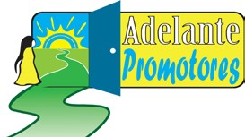
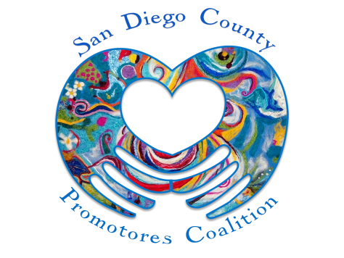

ADELANTE PROMOTORES ANNUAL CONFERENCE

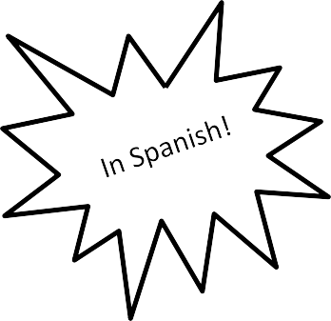
Friday, August 11, 2017
8:00 AM to 4:30 PM
Marina Village Conference Center
Mission Bay Park, 1936 Quivira Way, San Diego, CA 92109
Call for Presenters and Facilitators

Registration information will be sent soon!

The San Diego County Promotores Coalition is proud to announce the 2017 Adelante Promotores Conference. The purpose of the Adelante Promotores Conference is to motivate, educate, and increase the skills of the Promotores/ Community Health Workers and provide tools to help them in their noble work and promote health and wellness in families and communities.

The objectives of the conference are:

Objective 1 (Tables) | Objective 2 (Workshops) | Objective 3 (Workshops)
Increase awareness of health issues  (Diabetes, Hypertension, Mental Health, Cancer, Obesity, Domestic Violence, and more) | Increase the professional skills of the Promotores (Professionalism, Cultural Competency, Advocacy, Leadership, Organization, and more) | Increase personal skills of the Promotores (Communication, Self-Esteem, Interpersonal Skills, Stress Management, and more)

If you have any questions or need more information, please contact: Margarita Holguin at (619) 427-2290 or at Margarita.holguin@cvesd.org
Adelante Promotores Conference

Are you an expert in one of the topics related to the conference objectives?
Would you like to share your knowledge and skills?

We invite you to present a workshop or facilitate a “Conversation Table” at the conference!

If you are interesting in presenting a workshop or facilitate a health topic in a conversation table, please complete the attached proposal.

Topics of objective 1 will be presented through “Conversation Tables" with approximately 8 participants. Each facilitator of the “Conversation Tables” will provide two conversations (same topic) for about 30 minutes each.
Topics of objectives 2 and 3 are presented through workshops – workshops are approximately 90 minutes long.

Name: Telephone: Organization: Address: E-mail:

Proposals are due by
June 1, 2017

Please submit by e-mail to:Margarita.holguin@cvesd.org or FAX (619) 427-6954
If you have any questions or need more information, please contact Margarita Holguin at (619) 427-2290.
Our visit our website at www.SDCpromotores.org

Request to facilitate a “Conversation Table”

Please indicate which health topic your conversation table will address:

Topic:

Title of Conversation:
___

Your presentation will be in: Spanish _
___
English

Conversation table description:
(30 words max – this description will be listed in the conference program)
Click here to enter text.

What knowledge or experience do you have in the health topic that aims to facilitate a conversation table?
Click here to enter text.

Proposals are due by June 1, 2017
Request for Workshop presentation

We provide copies of all presentations to attendees; are you willing to provide an electronic copy of your presentation? Yes No

Please indicate which of the conference objectives your workshop will address:

_____ Topic 2: Increase of professional skills the Promotores
___
___
_____ Topic 3: Increase personal skills of the Promotores

Workshop Title:
___

Your presentation will be in: Spanish _
English__

Brief workshop description (max 30 words - this will be listed for workshop registration):
Click here to enter text.

Full workshop description (max 150 words - this description will be listed in the Conference program):
Click here to enter text.

Provide your biography (max 150 words – will be included in the program):
Click here to enter text.

Proposals are due by June 1, 2017

You will be notified if your proposal is accepted. If accepted, we ask that you provide the workshop description

and biography both in English and Spanish to be included in the conference program.

