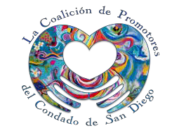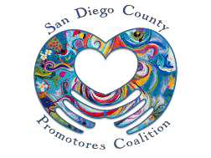

San Diego County Promotores Coalition
Empowering Promotores Since 2011
Margarita Holguin, MPA Prisci Quijada, MPH
Coalition Co-Chair Coalition Co-Chair
Monthly Meeting
Wednesday, July 19, 2017

12:00 – 2:00p.m.
Chula Vista Community Collaborative
540 G Street, Chula Vista, Ca 91910

Teleconference Number:
1 (888) 923-9066
Access Code: 5330662#

Agenda
Time | Activity
12:00 - 12:05pm | Welcome and Introductions
12:05 - 12:15pm | Review of June 21, 2017 meeting minutes
12:15 - 12:35pm | Discussion: Computer Literacy Trainings
12:35-12:55pm | Discussion: Coalition Account with Border Philanthropy Partnership
12:55-1:25pm | Discussion: Conference House Keeping
1:25 – 1:45pm | Committee Roles and Reports  - Membership & Sustainability: Prisci, Camille, Laura, Maria, Lupita, Elizabeth  - Conference: Margarita, Prisci, Nancy, Hermenia, Araceli, Arnold, Antolin, Elizabeth  - Communications: Alma, Arnold, Connie, Araceli, Antolin  - Environmental Scan: Shawn, Laura, Arnold, Victoria, Gerry
1:45 – 2:00pm | Member Updates
2:00pm | Adjourn

Thank you for your participation and support!

Our next meeting is Wednesday, August 16, 2017 – 12-2pm, please refer the monthly meeting agenda for location.

Agendas are sent out before meetings via email. Contact Arnold Noriega, Office of Binational Border Health at arnold.noriega@cdph.ca.gov for meeting information.

(619) 567-6653 • SDCpromotores@gmail.com
sdcpromotores.org

