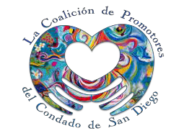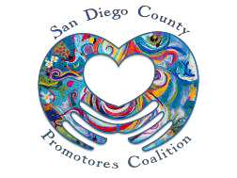

San Diego County Promotores Coalition
Empowering Promotores Since 2011
Margarita Holguin, MPA Prisci Quijada, MPH
Coalition Co-Chair Coalition Co-Chair
Monthly Meeting
Wednesday, June 21, 2017

12:00 – 1:30p.m.
CARE Community Center, IMPACT Room
12 North Euclid Avenue, National City, CA 91950

Teleconference Number:
1 (888) 923-9066
Access Code: 5330662#

Agenda
Time | Activity
12:00 - 12:05pm | Welcome and Introductions
12:05 - 12:15pm | Review of March 15, 2017 meeting minutes
12:15 - 12:30pm | Discussion of Technical Assistance for Agencies from the Office of Minority Health  Presented by Margarita Holguin
12:30 – 1:00pm | Committee Roles and Reports  - Membership & Sustainability: Prisci, Camille, Laura, Maria, Lupita, Elizabeth  - Conference: Margarita, Prisci, Nancy, Hermenia, Araceli, Arnold, Antolin, Elizabeth  - Communications: Alma, Arnold, Connie, Araceli, Antolin  - Environmental Scan: Shawn, Laura, Arnold, Victoria, Gerry
1:00 – 1:30pm | Member Updates
1:30pm | Adjourn

Thank you for your participation and support!

Our next meeting is Wednesday, July 19, 2017 – 12-2pm, please refer the monthly meeting agenda for location.

Agendas are sent out before meetings via email. Contact Arnold Noriega, Office of Binational Border Health at arnold.noriega@cdph.ca.gov for meeting information.

(619) 567-6653 • SDCpromotores@gmail.com
sdcpromotores.org

